**2nd Grade Wildcat Times**

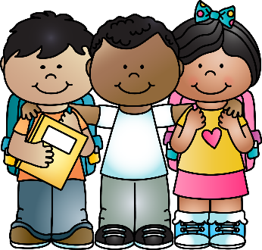**August 10-14**

WELCOME to a brand-new school year! We have truly enjoyed getting to know your child and we look forward to a great school year! Thank you for all supplies brought in. We definitely appreciate it! ☺

**Reading- Asks and answers questions?**

*Who is the main character? Where does the story take place? What happened in the beginning, middle and end?*

**Writing- Intro to Narrative**

*What connections do you have to the text?*

**LA- Nouns**

*What is a common noun? What is a proper noun?*

**Math- Place Value**

*What is the place of a number? What is the value of a number?*

**Science/Social Studies-**

**Spelling (practice nightly for Friday’s test):**

*Pattern:*

*Spelling will begin the week of August 17th.*

Reminders

* **Ice cream will be on sale from Wednesday 7-29-20 until Wednesday 8-12-20. We will sell ice cream for 33 Fridays this school year beginning on 8-14-20 and ending on 5-21-21. You can purchase a pre-paid ticket for $30 which means you get 3 free weeks!!! Tickets that are not redeemed are non-refundable. Frozen Friday can also be paid online at:** [**https://paulding.revtrak.net/elementary-schools/union-es/union-es-frozen-friday/**](https://paulding.revtrak.net/elementary-schools/union-es/union-es-frozen-friday/)
* **Please place all money in a Ziploc bag with your child’s name on it and what it is for.**
* **Please pack a snack for your child daily. We have a working snack, so it needs to be quick and simple (eaten one-handed). Water bottles are encouraged because students can use water fountains for refill water bottle only, no juice/tea please.**



**August 10-14 – Spirit Wear is on sale**

Union's motto for success is to be respectful, be responsible, and to be safe. We love to praise kids for these positive behaviors.

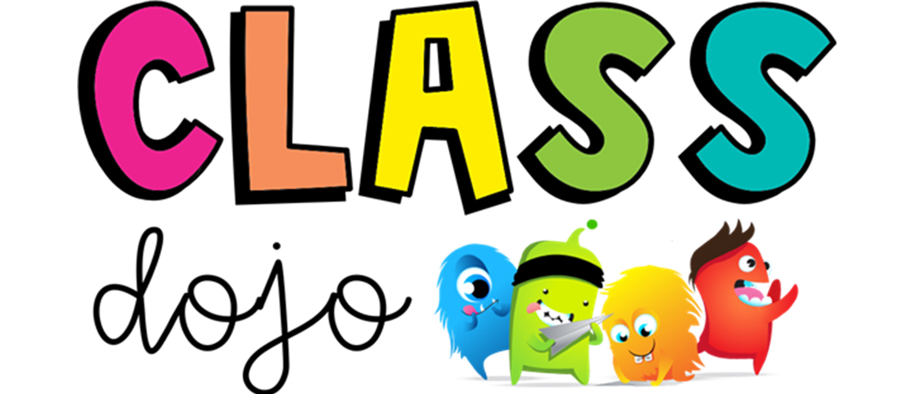

Please remember to check Class Dojo daily to see how well your child is doing.

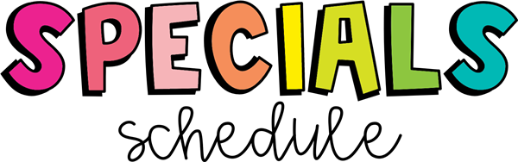

|  |  |  |  |  |  |
| --- | --- | --- | --- | --- | --- |
|  | **M** | **T** | **W** | **Th** | **F** |
| **Bowling** | M | A | PE | L | STEM |
| **Davis** | STEM | M | A | PE | PE |
| **Dunlap** |  |  |  |  |  |
| **Mills** | PE | L | M | A | L |
| **Quinn** | A | PE | L | M | A |

Please wear sneakers for PE.



Homework will begin the week of August 17th. Please have your child complete it nightly and review it with your child.